Q.1 a. Solution

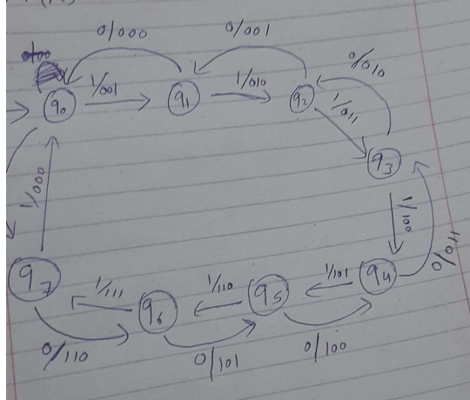

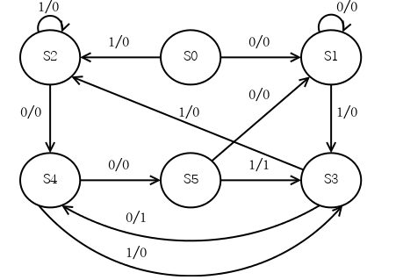

Q.2 Solution

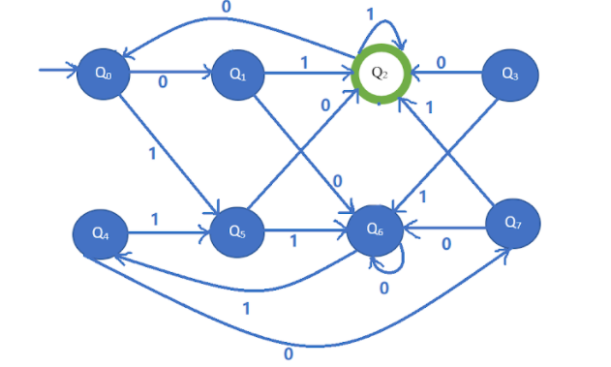

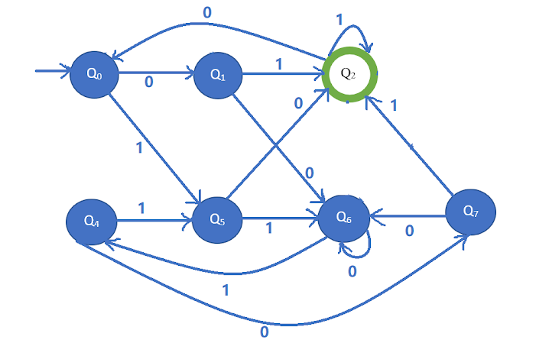

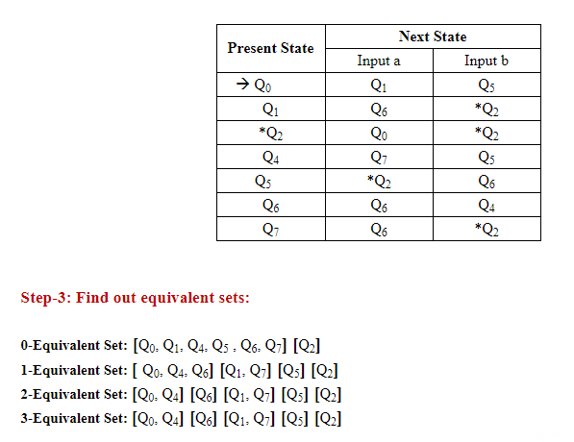

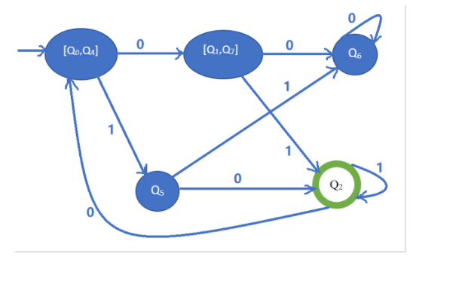

Q3. Solution

Part A. In line iii., Bilal did wrong split of w. As 0 is finite in w, therefore cannot be pumped and hence invalidate the proof. In another words, Bilal is not permitted to pick a specific split of w.

Part B. In line iii, Amjad didn't split s correctly. Since the given language is regular with p ≥2, therefore the we can write s=02p as s=ϵ 00 02(p−1) (x=ϵ, y=00, z=02(p−1)). We have |ϵ00|≤ p, |00|>1 and (00)i02(p−1) ∈ L for all i≥0.

Q. 5 Solution

1. S--> aSb|aaS|Sbb|∆
2. S-->aSb|aaa
3. Language is not CFL